Report: the Neural Network Model

**Overview** of the analysis: Explain the purpose of this analysis.

* The purpose of this analysis is to examine how the Neural Network model works.

**Results:**

* + What variable(s) are the target(s) for your model?

The column: Target=’IS_SUCCESSFUL’

* + What variable(s) are the features for your model?



* + What variable(s) should be removed from the input data because they are neither targets nor features?

“Name” & “EIN”

They should be removed because they are not targets nor features.

* **Compiling, Training, and Evaluating the Model**
  + How many neurons, layers, and activation functions did you select for your neural network model, and why?

3 layers, 100 neurons

* + Were you able to achieve the target model performance?

No. The maximum was 74.25

* + What steps did you take in your attempts to increase model performance?

Utilizing hidden layers, manipulating activation model and neurons.

* **Summary**: Summarize the overall results of the deep learning model. Include a recommendation for how a different model could solve this classification problem, and then explain your recommendation.

Overall results resulted in a status that is satisfactory despite several downfalls. The data utilized needed cleaning with data which was deemed unuseful including several columns to eliminate and values that would hinder the performance given they were too small in size. It is important to be diligent in the evaluating the data and seeing how we will progress with it in terms of model and with the testing and evaluation of it.

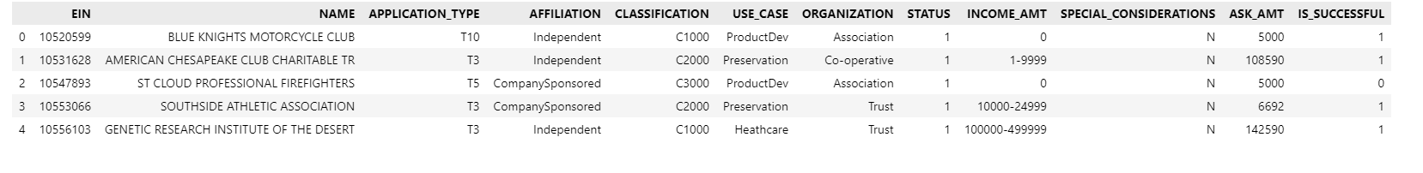

Train the model:

Save info in the HDF5 file:

